# Project Report

# Image Forgery Detection using ELA and CNN

**Objective**

The objective of this project is to develop a Convolutional Neural Network (CNN) model for detecting image forgeries, differentiating between real and manipulated images. The project leverages Error Level Analysis (ELA) as a preprocessing step to enhance the discriminative features in the images.

**Methodology**

1. Data Collection:

• Utilize the CASIA dataset, containing authentic and tampered images(spliced and copy-moved images, as well as images affected by post-processing operations such as filtering and blurring), for training and evaluation.

• Use ELA to preprocess images, enhancing the visual artifacts of manipulation.

1. ELA Preprocessing:

• Implement the ELA algorithm to highlight error levels in the images.

• Adjust the ELA parameters such as quality and scaling for optimal results.

• Integrate ELA preprocessing into the data pipeline.

1. Model Architecture:

• Design a CNN architecture for image forgery detection.

• The CNN should take ELA-enhanced images as input.

• Include convolutional layers, pooling layers, dense layers, and dropout layers for regularization.

1. Data Augmentation:

• Apply data augmentation techniques to artificially increase the size of the training dataset.

• Augmentation may include rotation, flipping, and zooming.

1. Model Training:

• Train the CNN using the preprocessed images.

• Use a binary classification setup with labels (real/fake).

• Monitor training progress with validation data and implement early stopping.

1. Model Evaluation:

• Evaluate the model's performance on a separate validation set.

• Visualize confusion matrices to understand model behavior.

1. Hyperparameter Tuning:

• Experiment with hyperparameter tuning to optimize model performance.

• Adjust learning rates, batch sizes, and network architecture.

1. Interpretability and Visualization:

• Visualize feature maps and activations to understand what the model learns.

• Use visualization tools to identify areas of interest in manipulated images.

**Model Architecture**

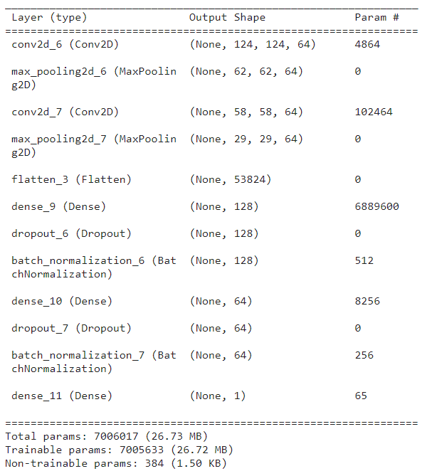

**RESULT**

True = Forged image

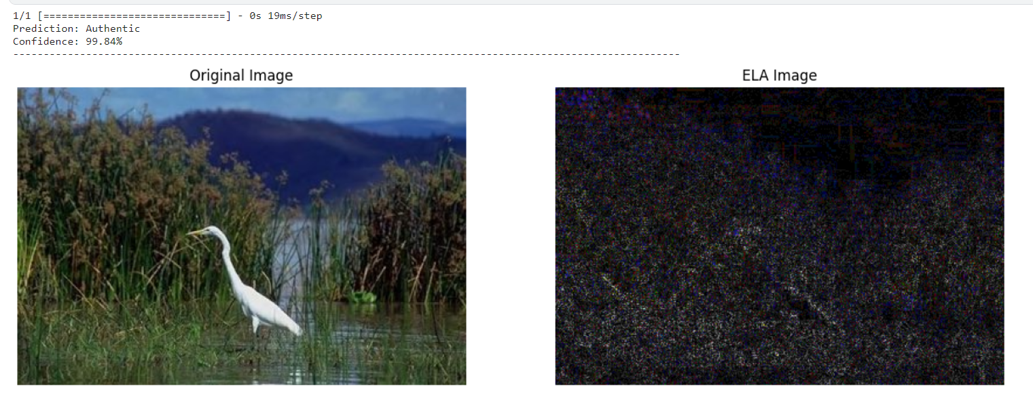True = Authentic image